SUBJECT 15

THE HOME FRONT IN BRITAIN DURING WORLD WAR II

Points to study:

- What is the Home Front?
- Who was involved in the Home Front?
- Why was the Home Front important in the war effort?
- What methods were used to build morale of the Home Front?
- What was daily life like in the Home Front?
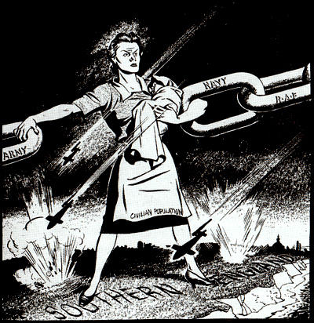

Philip Zec, "There is no weak link", The Daily Mirror (4th July, 1944)

https://spartacus-educational.com/U3Ahistory61.htm
- What the link with science and the home front?
- What happened to civil liberties in Britain during WW2?
- How was the war effort financed?

Source A

THE HOME FRONT IN BRITAIN DURING WORLD WAR II
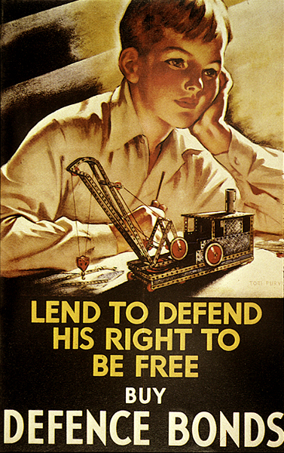
A poster by Tom Purvis for the National Savings Committee.
Date: 1942; Designer: Tom Purvis (1888 - 1959); Printer: J Weiner Ltd / Publisher: National Savings Committee; Size: 380mm x 255mm)
Famed for his pre-war dramatic use of flat colour, Purvis adopted a much more naturalistic approach in this 1942 War Bonds poster. Based on his son, John, the design is a touching and powerful ‘call-to-action’ to preserve family values threatened by military defeat.

https://www.twentiethcenturyposters.com/products/lend-to-defend-1942

Source B
THE HOME FRONT IN BRITAIN DURING WORLD WAR II

Rationing in Britain during WW2
Steve WAUGH, John WRIGHT, War and the transformation of British Society, 1931-1951, GCSE Modern World History, Hodder Education, 2014

Source C

SUBJECT 16

THE HOME FRONT IN BRITAIN DURING WORLD WAR II

Points to study:

- What is the Home Front?
- Who was involved in the Home Front?
- Why was the Home Front important in the war effort?
- What methods were used to build morale of the Home Front?
- What was daily life like in the Home Front?
- What the link with science and the home front?
- What happened to civil liberties in Britain during WW2?
- How was the war effort financed?

Source F :
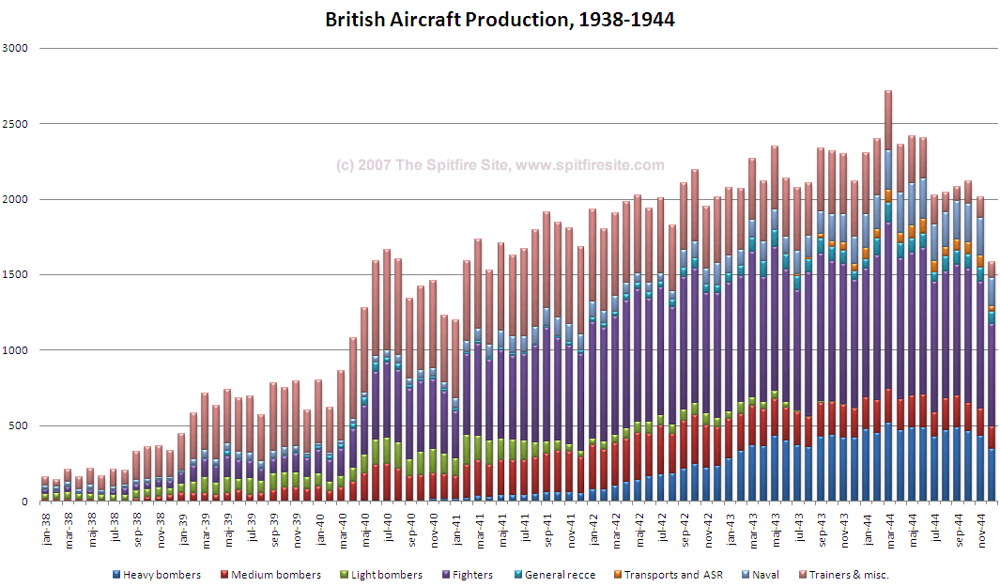

http://spitfiresite.com/2010/04/british-aircraft-production-1938-1944-monthly-deliveries-of-new-aircraft.html/2

Source A

THE HOME FRONT IN BRITAIN DURING WORLD WAR II
Women’s Voltuntary Service (WVS) providing Welfare
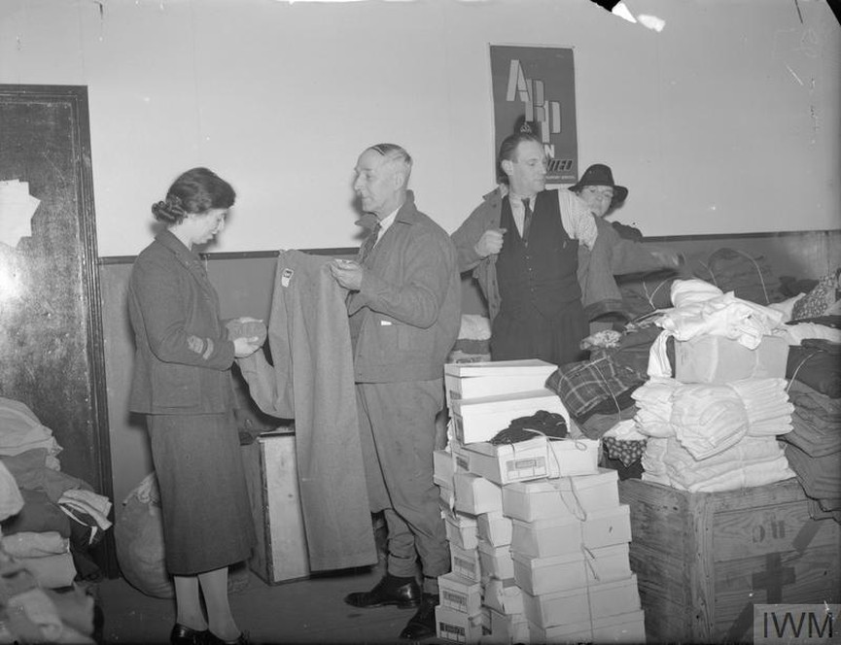
EAST HAM INFORMATION BUREAU: WAR WELFARE WORK IN LONDON, 1941
In East Ham Town Hall, women of the Women's Voluntary Service (WVS) control the free issue of clothing to bombed-out citizens. Here one WVS member can be seen helping a man on with a new jacket (it appears that it was once an army tunic), and a second WVS member helps another man with a new pair of trousers. In the foreground, can be seen a pile of shoeboxes, and a crate stamped with the letters RC and a cross (probably to indicate that the contents has been collected by the Red Cross) can also be seen. A poster to encourage people to join the ARP is also visible.
Creator: Ministry of Information Photo Division Photographer ; Imperial War Museum Catalogue number: D 3231 ; Part of MINISTRY OF INFORMATION SECOND WORLD WAR OFFICIAL COLLECTION

The Women's Voluntary Service (WVS) was created in 1938. By the time war broke out on 3 September 1939, it had 165,000 members and by 1941, membership was 1 million. During the Blitz, the WVS provided a range of post-raid services including serving refreshments from mobile canteens and providing washing facilities. They also set up enquiry points at the scene and often had to break the news that a family member had been killed or injured.

https://www.iwm.org.uk/collections/item/object/205198532

Source B
THE HOME FRONT IN BRITAIN DURING WORLD WAR II
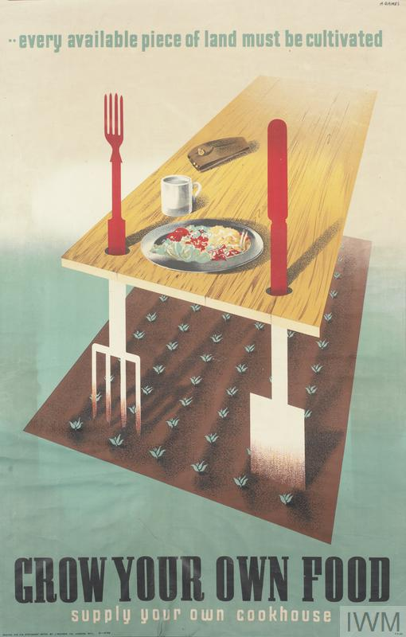
© IWM Art.PST 2893) Posters such as this one, produced in 1942, encouraged people to grow vegetables, which were not rationed but often in short supply.

https://www.iwm.org.uk/history/what-you-need-to-know-about-rationing-in-the-second-world-war

Source C

SUBJECT 17

THE HOME FRONT IN BRITAIN DURING WORLD WAR II

Points to study:

- What is the Home Front?
- Who was involved in the Home Front?
- Why was the Home Front important in the war effort?
- What methods were used to build morale of the Home Front?
- What was daily life like in the Home Front?
- What the link with science and the home front?
- What happened to civil liberties in Britain during WW2?
- How was the war effort financed?

Rationing in Britain during WW2
Steve WAUGH, John WRIGHT, War and the transformation of British Society, 1931-1951, GCSE Modern World History, Hodder Education, 2014

Source A

THE HOME FRONT IN BRITAIN DURING WORLD WAR II

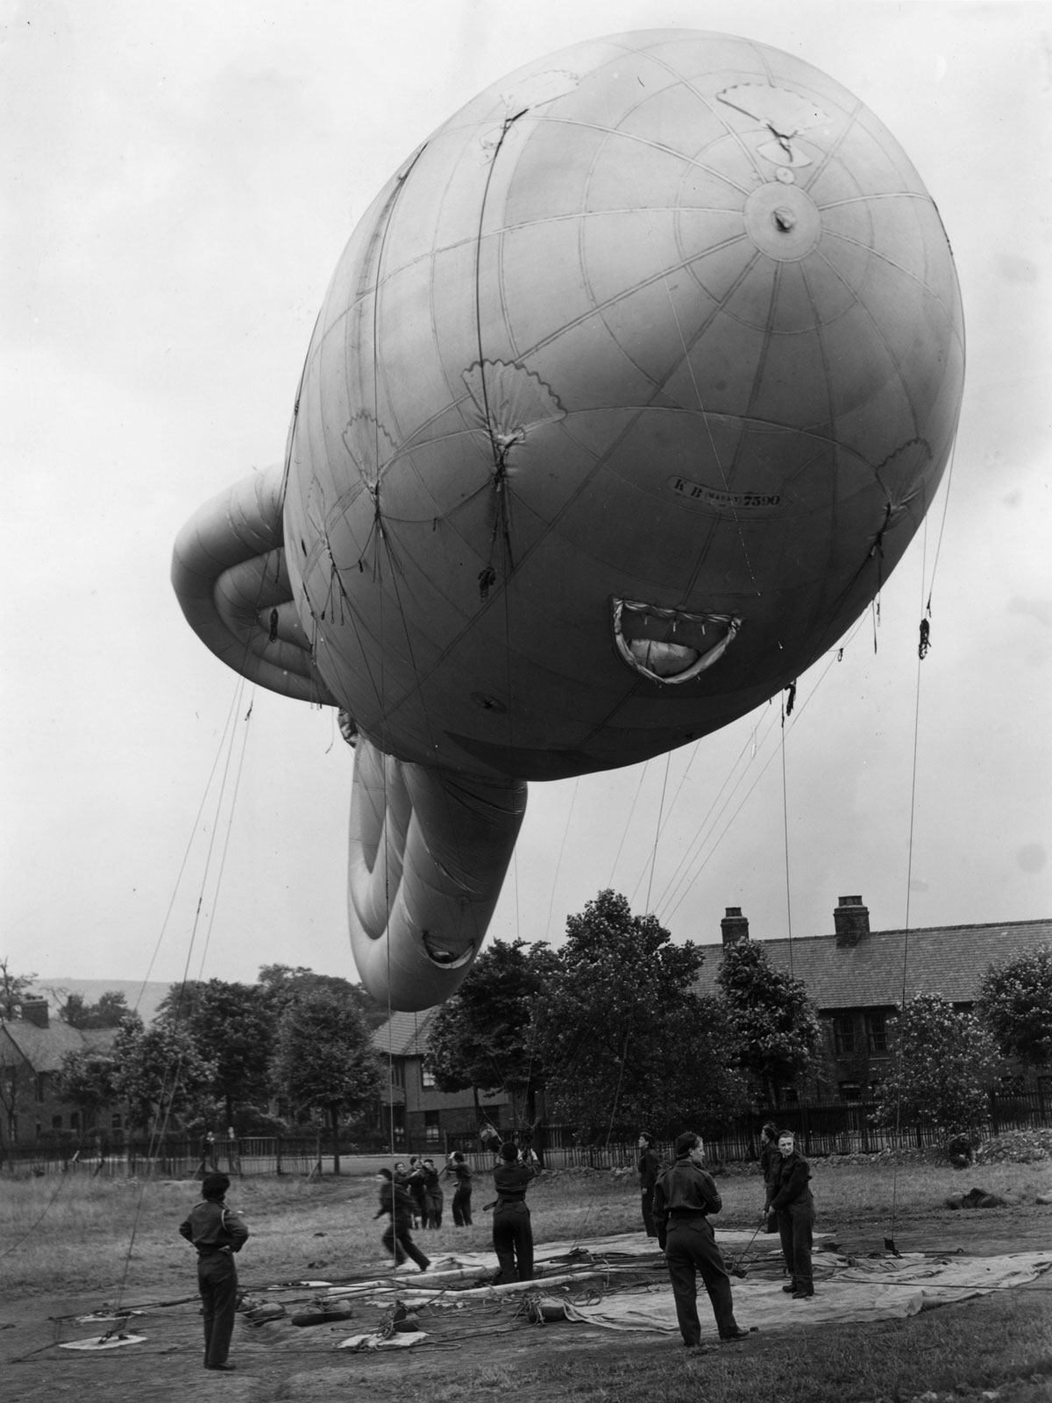
Women's Auxiliary Air Force (WAAF) ground crew tethering a barrage balloon, 1941.
H.F. Davis—Topical Press Agency/Hulton Archive/Getty Images

https://www.britannica.com/event/the-Blitz

Source B
THE HOME FRONT IN BRITAIN DURING WORLD WAR II
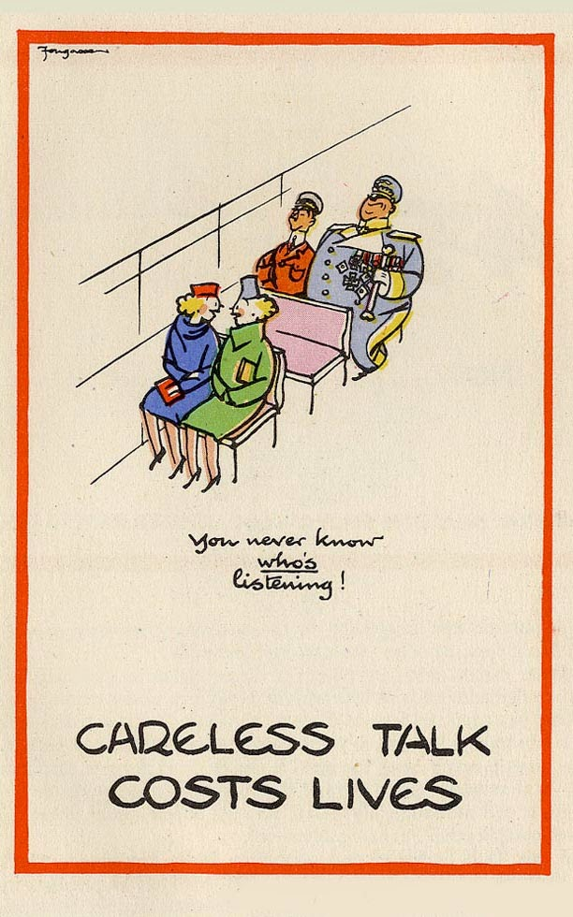
Fougasse (Cyril Kenneth Bird, 1887-1965) CARELESS TALK COSTS LIVES lithograph in colours, 1940, 32x22cm, color lithograph, and printed on paper (though some were originally issued affixed to cardboard or another stiffer board.

https://longstreet.typepad.com/thesciencebookstore/2017/12/iconic-wwii-propaganda-great-britain-1940.html

Source C
SUBJECT 18

THE HOME FRONT IN BRITAIN DURING WORLD WAR II

Points to study:

- What is the Home Front?
- Who was involved in the Home Front?
- Why was the Home Front important in the war effort?
- What methods were used to build morale of the Home Front?
- What was daily life like in the Home Front?
- What the link with science and the home front?
- What happened to civil liberties in Britain during WW2?
- How was the war effort financed?

Land Girls were paid less than men for the same work.

Land girls were paid directly by the farmers who employed them. The minimum wage was 28s per week and from this, 14s was deducted for board and lodging. The average wage for male agricultural workers was 38s per week. The basic working week for land girls was 48 hours in winter and 50 in summer. Initially there were no holidays – paid or unpaid, just a free travel pass after six months. However, conditions improved after 1943 with the introduction of the 'Land Girls Charter'. This introduced one week's holiday per year and raised the minimum wage.

https://www.iwm.org.uk/history/what-was-the-womens-land-army

Source A

THE HOME FRONT IN BRITAIN DURING WORLD WAR II

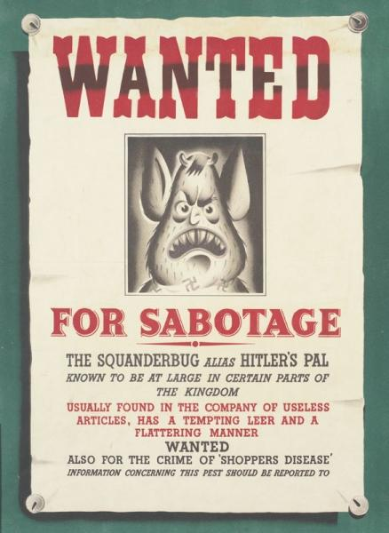
Creator: Boydell, Phillip , Stafford and Co Ltd, Netherfield, Nottingham (printer), National Savings Committee (publisher/sponsor) , Her Majesty's Stationery Office (publisher/sponsor), Support: paper ; medium: lithograph, Dimensions: Height 498 mm, Width 367 mm ; Imperial War Museum Catalogue number : Art.IWM PST 3406

This unpleasant-looking character is called the Squander Bug, and it was created during the Second World War by artist Phillip Boydell, an employee of the National Savings Committee. The Committee raised funds by urging the public to save their own money and invest it in the war effort. The cartoon bug appeared in press adverts and poster campaigns as a menace who encouraged shoppers to waste money rather than buy war savings certificates. The campaign was extremely popular, and the cartoon was adapted for use in other countries, including Australia and New Zealand. The American children’s author Dr Seuss created his own version of the Squander Bug for use in war savings campaigns in the United States.

https://www.iwm.org.uk/collections/item/object/3420

Source B
THE HOME FRONT IN BRITAIN DURING WORLD WAR II
Ruby Loftus screwing a Breech-ring, 1943, by Laura Knight 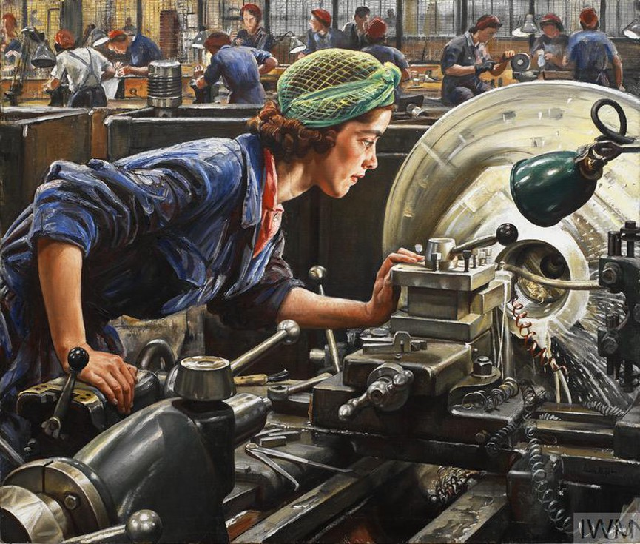
Ruby Loftus screwing a Breech-ring, 1943, by Laura Knight. Loftus is at her lathe in the Royal Ordnance Factory in Newport, South Wales. Miss Loftus had been brought to the attention of the War Artist's Advisory Committee as 'an outstanding factory worker'. Knight expected to do a studio portrait, but the Ministry of Supply requested that she be painted at work in the Royal Ordnance Factory in Newport.

Creator: Knight, Laura, Production date: 1943; Oil on canvas ; Dimensions: Height 863 mm, Width 1019 mm

Imperial War Museum Catalogue number: Art.IWM ART LD 2850

https://www.iwm.org.uk/collections/item/object/15504

Source C

SUBJECT 19

THE HOME FRONT IN BRITAIN DURING WORLD WAR II

Points to study:

- What is the Home Front?
- Who was involved in the Home Front?
- Why was the Home Front important in the war effort?
- What methods were used to build morale of the Home Front?
- What was daily life like in the Home Front?
- What the link with science and the home front?
- What happened to civil liberties in Britain during WW2?
- How was the war effort financed?

Rationing in Britain during WW2
Steve WAUGH, John WRIGHT, War and the transformation of British Society, 1931-1951, GCSE Modern World History, Hodder Education, 2014

Source A

THE HOME FRONT IN BRITAIN DURING WORLD WAR II

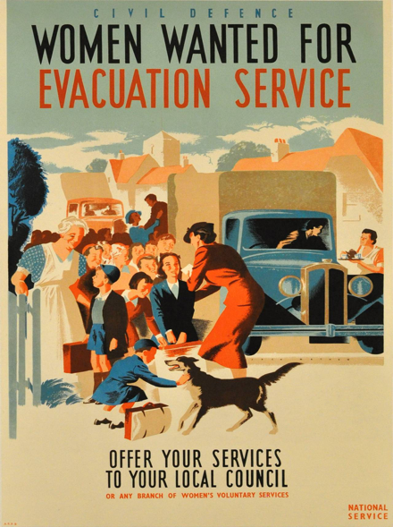
Creator: Mathew, Jack; publisher/sponsor: WOMEN'S VOLUNTARY SERVICES, NATIONAL SERVICE, ARP (Air Raid Precautions) ; Support: paper ; medium: lithograph ; Dimensions 763 mm x 508, Imperial War Museum, (Catalogue number: Art.IWM PST 15092).

https://www.iwm.org.uk/collections/item/object/17604

Source B
THE HOME FRONT IN BRITAIN DURING WORLD WAR II
A royal visit to the Leyland Factory, England, UK, 1941
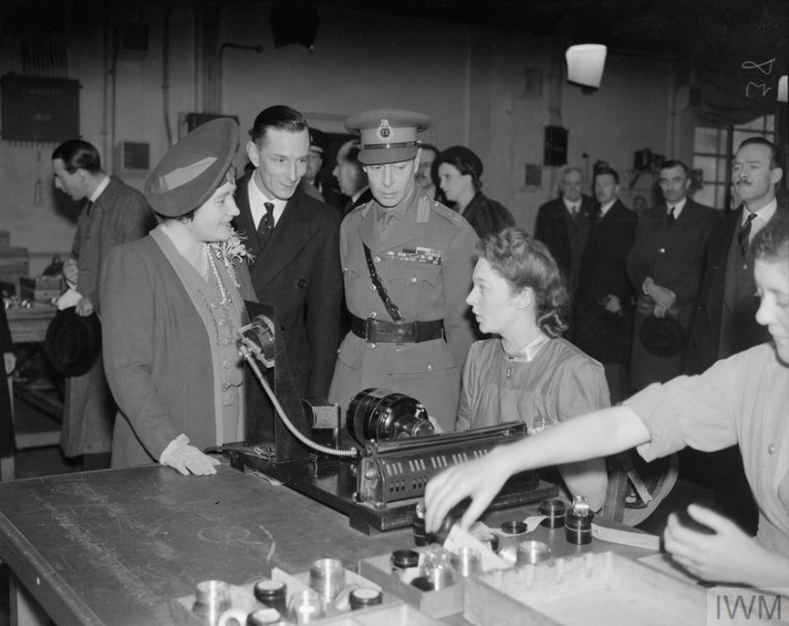
HM King George VI and HM Queen Elizabeth talk to a woman operating a fuse testing machine during a visit to the Royal Ordnance factory in Blackburn. Factory superintendent Stephen van Ryssen escorts them.

Creator: Ministry of Information official photographer ; Imperial War Museum Catalogue number : P 399 ; Part of MINISTRY OF INFORMATION SECOND WORLD WAR OFFICIAL COLLECTION

The King and Queen took a real interest in the work that people were doing. This raised morale and gave factory workers a renewed enthusiasm for their work. The Ministry of Supply studied the effects of royal visits and found that, in most cases, production figures dropped on the day of the visit but the weekly production figures invariably rose.

https://www.iwm.org.uk/history/what-the-royal-family-did-during-the-second-world-war

Source C

SUBJECT 20

THE HOME FRONT IN BRITAIN DURING WORLD WAR II

Points to study:

- What is the Home Front?
- Who was involved in the Home Front?
- Why was the Home Front important in the war effort?
- What methods were used to build morale of the Home Front?
- What was daily life like in the Home Front?
- What the link with science and the home front?
- What happened to civil liberties in Britain during WW2?
- How was the war effort financed?
At an ATS motor transport company training centre in 1941
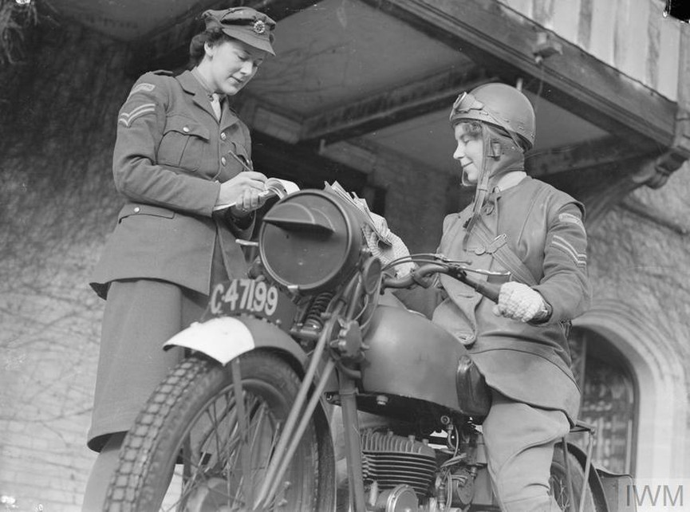
Motorcycle messenger at the Auxiliary Territorial Service (ATS) training centre, Camberley, 1941.

Creator: Ministry of Information Photo Division Photographer ; Imperial War Museum Catalogue number: D 5721 ; Part of MINISTRY OF INFORMATION SECOND WORLD WAR OFFICIAL COLLECTION

The Women's Auxiliary Air Force was founded in June 1939 to free up RAF personnel for front line duties. By 1943, the WAAF had 182,000 members. WAAFs undertook a variety of roles, including compiling weather reports, maintaining aircraft, serving on airfields and working in intelligence.

https://www.iwm.org.uk/collections/item/object/205195831

Source A

THE HOME FRONT IN BRITAIN DURING WORLD WAR II
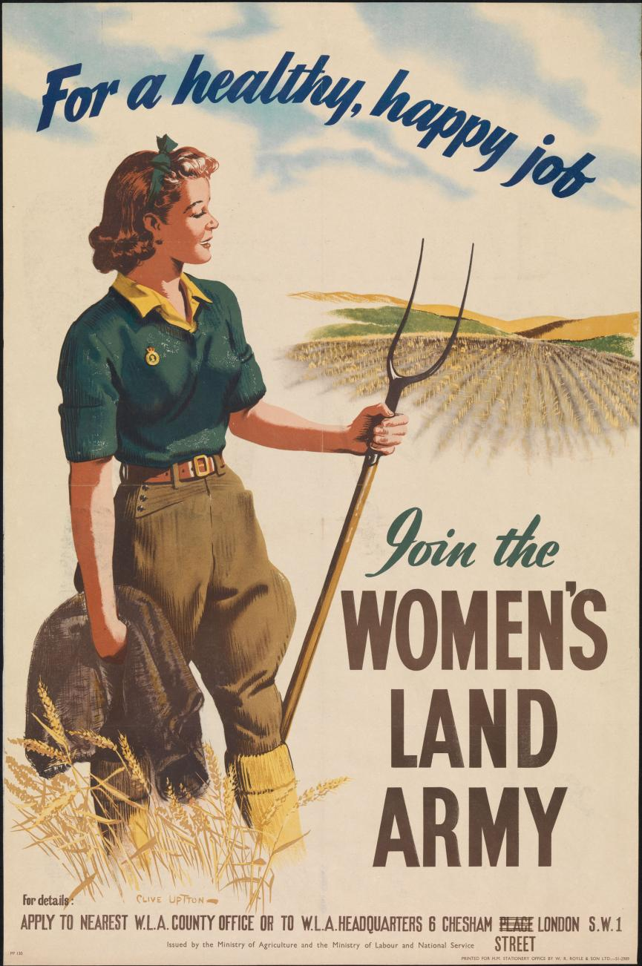
Creator Uptton, Clive ; Support: paper ; medium: photolithograph Dimensions: Height 730 mm x 484 mm, Imperial War Museum, London, (Catalogue number
Art.IWM PST 6078)

https://www.iwm.org.uk/collections/item/object/36790

Source B
THE HOME FRONT IN BRITAIN DURING WORLD WAR II

‘How our saucepans built the Spitfires that won the Battle of Britain’
New Spitfire Gallery set to be opened at Birmingham's Thinktank Science Museum
By Justine Halifax, 22 MAR 2015, Bimingham Mail

They are the world’s most famous, and most admired, fighter planes – but they hid a secret.
Some of them were built with Saucepans donated by Castle Bromwich housewives. The cooking utensils were handed over to be melted down and re-used in Spitfires which were being churned out, round-the-clock, in local factories during World War II. At that stage of the war Brummies knew just how vital the Spitfire was to the war effort – and the city was united in helping. “The commitment of Brummies to the Spitfire was profound,” says Birmingham historian Carl Chinn. “Even saucepans were handed in to help make them, and in 1940 a Spitfire Fund collected £4,387. “It included a donation of £75 made by children at Golden Hillock Road Junior and Infant Schools. “Little wonder that the names of Birmingham and the Spitfire are so bonded.”

[…] Birmingham suffered brutal bombing raids as the enemy tried to target key aircraft factories. With over half of the total tally of Spitfires rolling off production lines at Castle Bromwich, it was high on the enemy’s hitlist. In all, more than 11,000 Spitfires were built at the factory by 6,000 workers, some of whom paid with their lives. Six were killed during one bombing raid on the night of August 13, 1940.
.

https://www.birminghammail.co.uk/news/midlands-news/how-saucepans-built-spitfires-won-8892852

Source C

SUBJECT 21

THE HOME FRONT IN BRITAIN DURING WORLD WAR II

Points to study:

- What is the Home Front?
- Who was involved in the Home Front?
- Why was the Home Front important in the war effort?
- What methods were used to build morale of the Home Front?
- What was daily life like in the Home Front?
- What the link with science and the home front?
- What happened to civil liberties in Britain during WW2?
- How was the war effort financed?

A Spitfire factory in Birmingham during WW2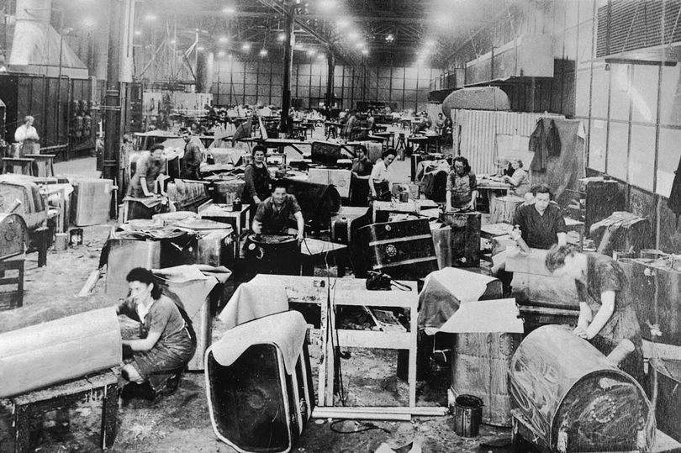
Women workers preparing Spitfire parts for spraying in Birmingham during the Second World War.

https://www.birminghammail.co.uk/news/midlands-news/how-saucepans-built-spitfires-won-8892852

Source A

THE HOME FRONT IN BRITAIN DURING WORLD WAR II
Creator : Tunbridge, Mary , Printer: H. Manley & Son Ltd,
Publisher/sponsor: Her Majesty's Stationery Office, MINISTRY OF AGRICULTURE AND FISHERIES
Support: paper ; medium: lithograph ; Dimensions: Height: 381 mm, Width:252
Imperial War Museum Catalogue number: Art.IWM PST 0696

https://www.iwm.org.uk/collections/item/object/26611

Source B
THE HOME FRONT IN BRITAIN DURING WORLD WAR II
The Vital Role of Women in The Second World War

Women were conscripted in December 1941. They were given a choice of working in industry or joining one of the auxiliary services – the Auxiliary Territorial Service (ATS), the Women's Auxiliary Air Force (WAAF) or the Women's Royal Naval Service (WRNS).

The ATS was formed in 1938. Initially, the only jobs available were cooks, clerks, orderlies, store women or drivers. But eventually there were over a hundred different roles in the ATS, including serving in anti-aircraft batteries. This expansion allowed more men to be released for front line service. More than 250,000 women served in the ATS during the Second World War, making it the largest of the women's services.

The Women's Auxiliary Air Force was founded in June 1939 to free up RAF personnel for front line duties. By 1943, the WAAF had 182,000 members. WAAFs undertook a variety of roles, including compiling weather reports, maintaining aircraft, serving on airfields and working in intelligence.

The Women’s Royal Naval Service was reformed in April 1939. Women were recruited for shore-based jobs to release men for service at sea. By 1943, there were 74,000 WRNS (or 'Wrens') serving in the UK and overseas. Wrens played a major part in the planning and organisation of naval operations. From 1941, Wrens served at Bletchley Park and its outstations operating machines used in code-breaking.

Women also volunteered for the First Aid Nursing Yeomanry (FANY), Women's Voluntary Service (WVS) or served in Civil Defence, the National Fire Service, Air Transport Auxiliary (ATA) or in military nursing.

https://www.iwm.org.uk/history/the-vital-role-of-women-in-the-second-world-war

Source C
SUBJECT 22

THE HOME FRONT IN BRITAIN DURING WORLD WAR II

Points to study:

- What is the Home Front?
- Who was involved in the Home Front?
- Why was the Home Front important in the war effort?
- What methods were used to build morale of the Home Front?
- What was daily life like in the Home Front?
- What the link with science and the home front?
- What happened to civil liberties in Britain during WW2?
- How was the war effort financed?

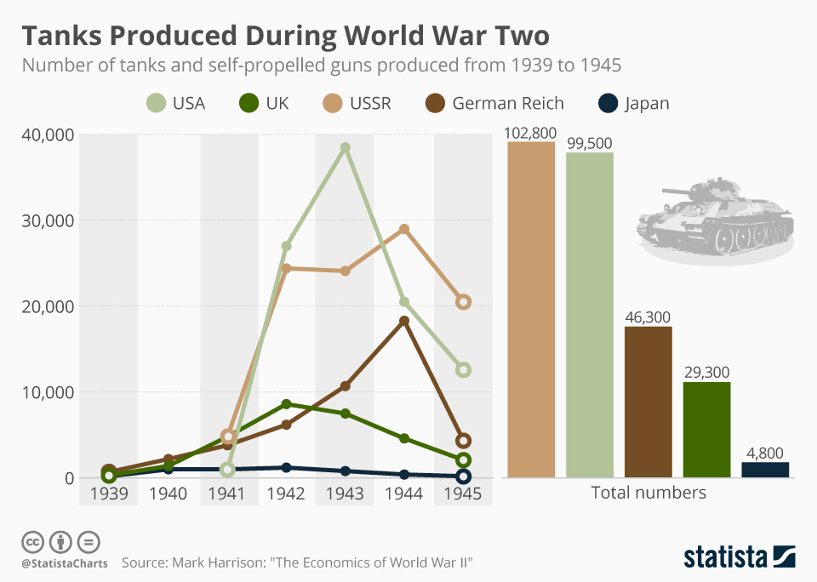
https://cdn.statcdn.com/Infographic/images/normal/8269.jpeg

Source A

THE HOME FRONT IN BRITAIN DURING WORLD WAR II
An Air Raid Protection (ARP) Warden, Barbara Nixon in 1941
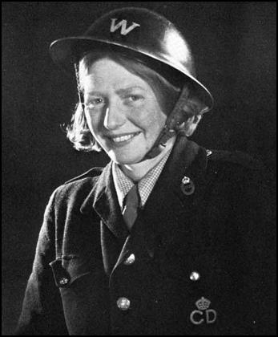
Barbara Nixon, an actress, became a voluntary (part-time) warden. "By the time that I joined, the public was already grumbling that the full-time Civil Defence personnel were a waste of money - a set of slackers, after easy jobs... I was given a tin hat, a whistle, and a CD respirator. The Post Warden one afternoon conducted me on the tour of the seventeen public shelters in the area... I gathered that a warden's main duty was to report any bombs which fell in his area. The Post itself was in a basement of an old house. It was not strengthened in any way, but across the road was a sunk concrete pill-box, which, later, gave good proof of its strength. When 'yellow' stand-by warnings or alerts sounded, the Post Warden, or his Deputy, a messenger, and one or two other wardens moved over there, while the rest of us went off to our various sectors. The Post area was divided into six or seven of these." (12)

https://spartacus-educational.com/2WWairwardens.htm

Source B
THE HOME FRONT IN BRITAIN DURING WORLD WAR II
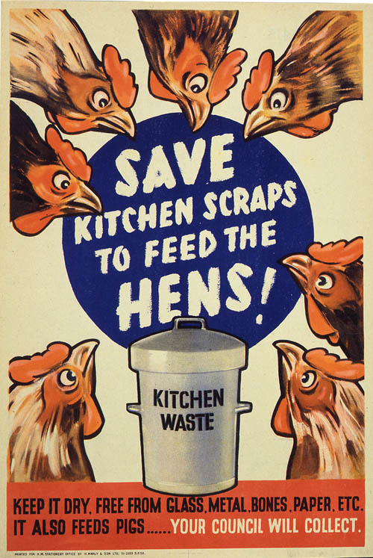
The image occupies the majority, with a smaller image positioned in the lower centre. The title is partially integrated and positioned at the centre, in white, held within a blue circular inset. The text is separate and located along the bottom edge, in black and in white, held within a red inset. Further text is integrated and placed in the lower centre, in black. All set against a white background. image: the heads of seven hens, looking inwards towards the centre of the poster. The smaller image is of a metal bin, marked 'Kitchen Waste'.
Creator: Unknown (Undefined); H Manly and Son Ltd, London N22 (printer); Her Majesty's Stationery Office (publisher/sponsor)
Place made: Great Britain
Materials: Support: paper; medium: lithograph

https://www.iwm.org.uk/collections/item/object/32261

https://www.nationalarchives.gov.uk/wp-content/uploads/2014/03/inf13-143131.jpg

Source C

SUBJECT 23

THE HOME FRONT IN BRITAIN DURING WORLD WAR II

Points to study:

- What is the Home Front?
- Who was involved in the Home Front?
- Why was the Home Front important in the war effort?
- What methods were used to build morale of the Home Front?
- What was daily life like in the Home Front?
- What the link with science and the home front?
- What happened to civil liberties in Britain during WW2?
- How was the war effort financed?

Children evacuation

Steve WAUGH, John WRIGHT, War and the transformation of British Society, 1931-1951, GCSE Modern World History, Hodder Education, 2014

Source A

THE HOME FRONT IN BRITAIN DURING WORLD WAR II
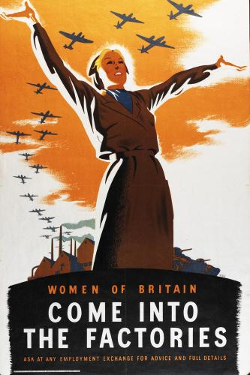
Creator : Zec, Philip ; Production date : 1941 ; Support: paper ; medium: photolithograph ; Size : Height 745 mm x 492 mm ;
Imperial War Museum Catalogue number : Art.IWM PST 3645

https://www.iwm.org.uk/collections/item/object/38928

Source B
THE HOME FRONT IN BRITAIN DURING WORLD WAR II
Land Army Girls during WW2
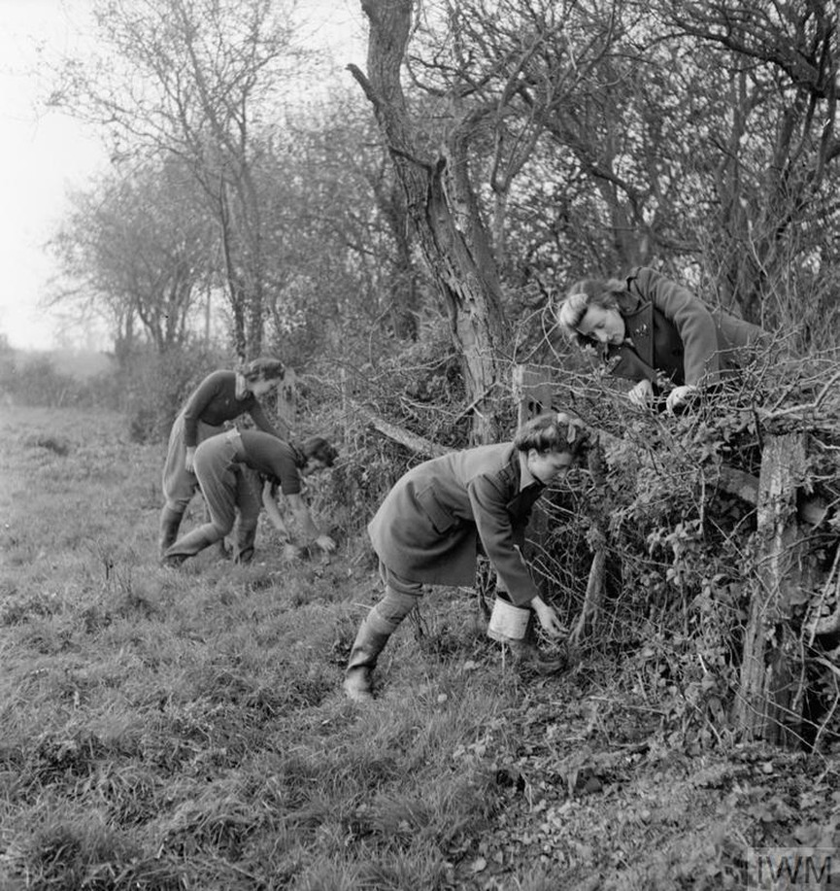
Land Girl Rat Catchers at work as part of their training on a Sussex farm. In the background Audrey Prickett and Betty Long plug a rat hole after inserting poison and in the foreground Eileen Barry lays some bait, as Audrey Willis leans over the hedge to check she is doing it properly.

Pests such as rats posed a serious threat to supplies of food and animal fodder on British farms. During wartime, there were thought to be over 50 million rats in Britain. To help counter this threat, teams of land girls were trained to work in anti-vermin squads. Two land girls are reputed to have killed 12,000 rats in just one year. Land girls in anti-vermin squads also were also trained to kill foxes, rabbits and moles.

Creator: Ministry of Information Photo Division Photographer
Imperial War Museum Catalogue number D 11256; Part of MINISTRY OF INFORMATION SECOND WORLD WAR OFFICIAL COLLECTION

https://www.iwm.org.uk/collections/item/object/205199698

Source C
SUBJECT 24

THE HOME FRONT IN BRITAIN DURING WORLD WAR II

Points to study:

- What is the Home Front?
- Who was involved in the Home Front?
- Why was the Home Front important in the war effort?
- What methods were used to build morale of the Home Front?
- What was daily life like in the Home Front?
- What the link with science and the home front?
- What happened to civil liberties in Britain during WW2?
- How was the war effort financed?
A tank factory in 1940
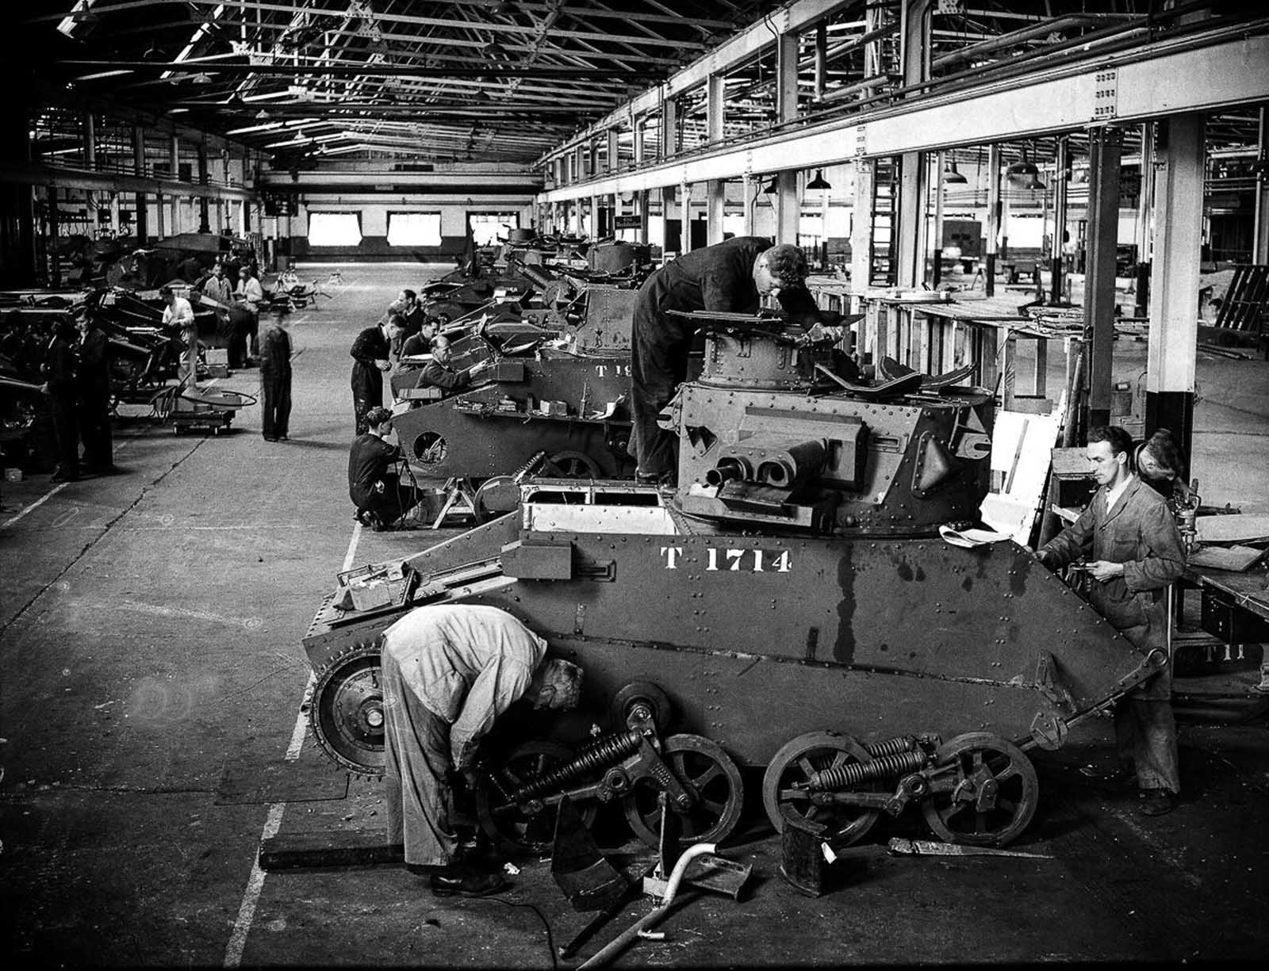
British tanks on an assembly line during Summer1940.

https://rarehistoricalphotos.com/tank-production-ww2/

Source A

THE HOME FRONT IN BRITAIN DURING WORLD WAR II
The image is positioned in the lower three-quarters. The title is partially integrated and positioned in the upper third, in dark blue. The text is separate and placed in the top edge left, in orange, and in the lower fifth, in black and in blue. All set against a white background. image: a three-quarter length depiction of a woman in ARP uniform, pulling on a pair of leather gloves. An ambulance is parked in the background right.

Creator: Brookshaw, Drake , publisher/sponsor : ARP (Air Raid Precautions
Support: paper ; medium: lithograph ; Dimension: Height 760 mm, Width : 505 mm
Imperial War Museum Catalogue number : Art.IWM PST 13864

https://www.iwm.org.uk/collections/item/object/3639

Source B
THE HOME FRONT IN BRITAIN DURING WORLD WAR II

Women in the Royal Observation Corps

In 1942, women volunteers were allowed to join men in their little lookout posts. Vera Charlton was in the northeast of the country, near Durham, and she joined up as soon as she could. She recalled: ‘The look-out post was built of cement. It was a small square building about eight or nine feet high with wooden floors and corners, and wooden things to stand on to look out. There was also a dugout with a wooden stove to heat things on, a shelter with a tiny little window and a Browning rifle. You had to learn how to fire that and how to fix bayonets – my father taught me how to as he was good at it.

‘We also had training lessons in the Odeon cinema in Newcastle on a Sunday when there were no shows on. The RAF would provide training films where an aircraft would appear on the screen for just a few seconds, and we would have to describe what it was. It was a sort of test, really, and there were also written tests on RAF procedures. In time I got my first class certificate but there was also an even higher grading, which was called the master test. For the master test, fifty aircraft would appear on the screen, one after another, and we had to correctly identify 95% of those aircraft … It wasn’t easy, but if you did pass you were given a little, pale-blue Spitfire badge to sew onto the sleeve of your battle dress.’

https://www.quartoknows.com/blog/quartodrives/the-royal-observation-corps-unsung-heroes-of-the-fighter-command.

Source C

